How to Use Dictation in Microsoft Office

Dictation in Microsoft Office
Turning on the dictation option in Office is as easy as a button click. On the Home tab in Word or PowerPoint, on desktop or online, click Dictate in the Voice section on the far right of the ribbon.
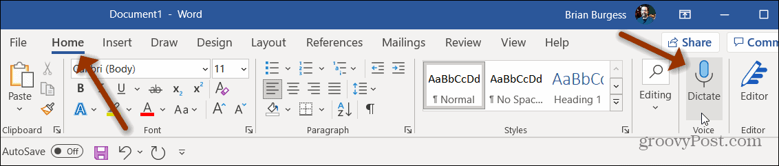
In Outlook, you’ll see the Dictate button on the right side of the ribbon when composing, replying to, or forwarding an email as well as when creating a new event in Outlook Calendar.
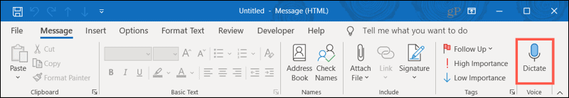

Use Dictation
After clicking the Dictate button:
- Start speaking immediately to dictate your words. You’ll see the small Dictation Toolbar appear.
- To pause, click the microphone icon in the toolbar and then again to resume. You can also use the command “pause dictation” and then click the icon to resume.
- To stop, click the X to exit dictation and close the toolbar or use the command “exit dictation.”
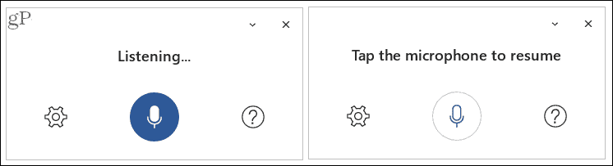

Adjust the Dictation Settings
You can adjust a few helpful settings for your dictation. Click the Dictation Settings (gear) icon in the Dictation Toolbar.
From there, you can choose a different language, enable automatic punctuation, and turn on a profanity filter.
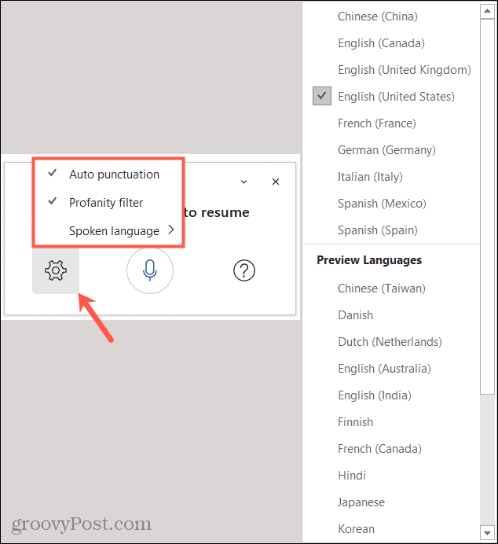

Supported Dictation Languages
Microsoft currently supports variations of English, Chinese, French, German, Italian, and Spanish. Other languages with limited support include Danish, Japanese, Polish, Portuguese, Russian, and several more with others being added over time.

Helpful Commands
When you’re composing a document, slideshow, or email, it’s not all about the words. You may need to add a bold font, include a special character, delete a word, or create a list. You can use dictation commands to take care of items like this as well. Here are several common commands.
Add punctuation: Say the name of the punctuation such as “period,” “comma,” “left bracket,” “right bracket,” “hyphen,” or “colon.”
Include symbols or characters: Just like adding punctuation, simply say what you want to add. Try things like “percent sign,” “minus sign,” “degree symbol,” “caret symbol,” dollar sign,” or “smiley face.”
Delete: To delete the last spoken item or one before the cursor, just say “delete.” You can also use “delete last [number] words or sentences” or “delete [word or phrase].”
Format text: You can use bold, italics, underline, strikethrough, and similar font formatting. After dictating the word or sentence, follow it with the formatting you want to use. For example, you could say “the water was cool and blue,” “bold blue.” This would then format the word “blue” in bold font. You can also use commands like “underline the last word” or “italicize the last sentence.”
Create lists: If you want a bullet or numbered list, simply create one with “start bullet list” or “start numbered list”. After dictating a list item, say “next line” to add another. When you finish, use the command “exit list”.
If you would like help at any time while dictating, just say “show help” or click the question mark in the Dictation Toolbar.

Punctuation
Phrase(s) | Output
period, full stop | .
comma | ,
question mark | ?
exclamation mark/point | !
new line | new line
apostrophe-s | 's
colon | :
semicolon | ;
open quotes  close quotes | " "
hyphen | -
ellipsis, dot dot dot | ...
begin/open single quote  end/close single quote | ' '
left/open parentheses  right/close parentheses | ( )
left/open bracket  right/close bracket | [ ]
left/open brace  right/close brace | { }

Editing
undo
delete*
delete that*
delete last [1-100] words/sentences
delete [word or phrase]*
insert space
backspace
backspace [1-100]
*Tips
- Saying “delete” by itself removes the last word or punctuation before the cursor.
- Saying “delete that” removes the last spoken utterance.
- An example of using [phrase] would be dictating “what a super nice day” and then saying “delete super.” You would then be left with the phrase "what a nice day."

Formatting
bold
italics
underline
strikethrough
<format*> [word or phrase]
superscript
subscript
indent
decrease indent
clear all formatting
align [left, center, right]
*Tips
- You can bold, italicize, underline, or strikethrough a word or phrase. An example would be dictating “review by tomorrow at 5PM”, then saying “bold tomorrow” which would leave you with "review by tomorrow at 5PM."
- Try phrases like “bold last word” or “underline last sentence.”

Creating lists
start list
start numbered list
next line
exit list

Adding comments
add comment [your message here]*
*Tips
- Saying “add comment look at this tomorrow” will insert a new comment with the text “Look at this tomorrow” inside it.
- Saying “add comment” by itself will create a blank comment box that can be manually typed into.

While dictating
show help
pause dictation
exit dictation*
*Tips
- To resume dictation, please use the keyboard shortcut (ALT + `) or press the Mic icon in the floating dictation menu.

Symbols
Phrase(s) | Output
asterisk | *
backslash | \
forward slash | /
vertical bar sign, pipe character | |
backquote, backtick | `
underscore | _
m-dash | —
n-dash | –
paragraph sign/mark | ¶
section sign | §
ampersand, and sign | &
at sign | @
copyright sign | ©
registered sign | ®
degree symbol | °
caret symbol | ^
Mathematics
Phrase(s) | Output
percent sign | %
number/pound sign | #
plus sign | +
minus sign | -
multiplication sign | x
plus or minus sign | ±
division sign | ÷
equal sign | =
less than sign, left angle bracket  greater than sign, right angle bracket | < >
Currency
Phrase(s) | Output
dollar sign | $
pound sterling sign | £
euro sign | €
yen sign | ¥
Emoji/faces
Phrase(s) | Output
smiley face | :)
frowny face | :(
winky face | ;)
heart emoji | <3

